California State University Fullerton

CPSC 462



Object Oriented Software Design

Vision and Business Case

for the

1. Update placeholder with your project’s title being careful not to delete the (potentially hidden) bookmark. If you did it right, the document’s footer will be updated too
2. Delete this bubble

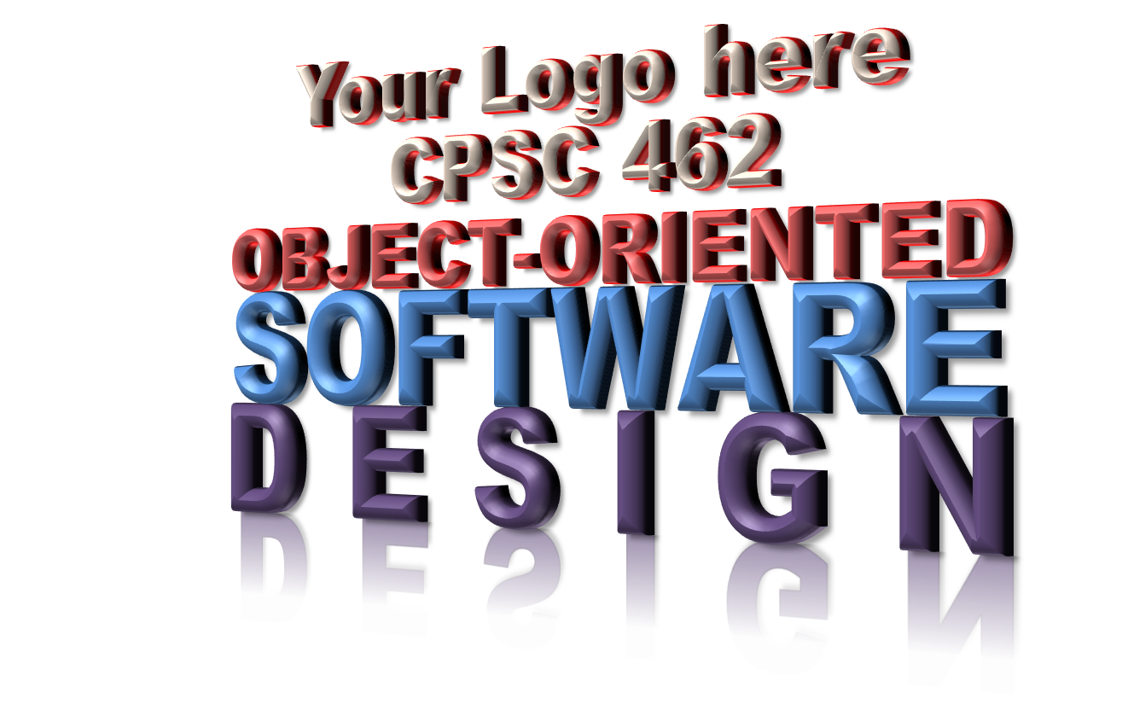

<Your Project Title here>

System

|  |  |  |
| --- | --- | --- |
| **<Student Name 1 here>** | **<Student Name 2 here>** | **<Student Name 3 here>** |
| <Title / Roll within project> | <Title / Roll within project > | <Title / Roll within project > |
| <[Email1@csu.fullerton.edu](mailto:Email1@csu.fullerton.edu)> | <[Email2@csu.fullerton.edu](mailto:Email2@csu.fullerton.edu)> | <[Email3@csu.fullerton.edu](mailto:Email3@csu.fullerton.edu)> |

Revision History:

| Version | Date | Summary of Changes | Author |
| --- | --- | --- | --- |
| 1.0 | <date of release> | * Initial Release | <Name 1>  <Name 2>  … |
|  |  |  |  |
|  |  |  |  |
|  |  |  |  |

Table of Contents

1 Executive Summary 1

2 Positioning 1

2.1 Business Opportunity 1

2.2 Problem Statement 1

2.3 Product Position Statement 1

2.4 Alternates and Competition 1

3 Stakeholder Descriptions 1

3.1 Market Demographics 1

3.2 Non-User Summary 1

3.2.1 <Stakeholder 1> 1

3.2.2 <Stakeholder 2> 1

3.3 User Summary 1

3.3.1 <Actor 1> 1

3.3.2 <Actor 2> 1

3.4 Key High-Level Goals and Problems of Stakeholders 1

3.5 User-level Goals 2

4 Product Overview 2

4.1 Product Perspective 2

4.2 System context diagram showing Primary and Supporting Actors 2

5 Summary of Benefits 2

6 Summary of System Features 2

7 Investment Summary 2

7.1 Cost Summary 2

7.2 Pricing Summary 2

7.3 Schedule Summary 2

7.3.1 Iteration Plan 2

8 Assumptions and Dependencies 2

9 Go / No-Go Decision 2

NOTE TO STUDENTS:

1. See Larman §7.6 Next Gen Example: (Partial) Vision and §7.7 Commentary: Vision
2. Delete this NOTE before you deliver

# Executive Summary

# Positioning

## Business Opportunity

## Problem Statement

## Product Position Statement

## Alternates and Competition

# Stakeholder Descriptions

## Market Demographics

## Non-User Summary

NOTE TO STUDENTS:

1. Identify Stakeholders by name, office, or role. Avoid generalizations. For example, don’t say “the government”, say “Unemployment Insurance Agency Michigan Web Account Executive Manager”. As a guideline, Stakeholders have a belly button and an eMail address.
2. Delete this NOTE before you deliver

### <Stakeholder 1>

…

### <Stakeholder 2>

…

## User Summary

NOTE TO STUDENTS:

1. Identify and group Actors by the role they are assuming when using this application. A single person may assume many roles, but that isn’t a concern here. Many individuals may assume a role, and that’s okay – it’s still one role and thus one Actor.
2. Delete this NOTE before you deliver

### <Actor 1>

…

### <Actor 2>

…

## Key High-Level Goals and Problems of Stakeholders

…

| Stakeholder | High-Level Goal | Priority | Issues / Problems | Interests / Solutions |
| --- | --- | --- | --- | --- |
| <Stakeholder 1> |  |  |  |  |
| <Stakeholder 2> |  |  |  |  |
| … |  |  |  |  |
| <Actor 1> |  |  |  |  |
| <Actor 2> |  |  |  |  |
| … |  |  |  |  |

## User-level Goals

# Product Overview

## Product Perspective

## System context Diagram

# Summary of Benefits

…

| Supporting Feature | Stakeholder Benefit |
| --- | --- |
|  |  |

# Summary of System Features

# Investment Summary

## Cost Summary

## Pricing Summary

## Schedule Summary

…

### Iteration Plan

NOTE TO STUDENTS:

1. See Larman §4.4 What Artifacts May Start in Inception, §24.1 From Iteration 1 to 2, §40.1 through §40.5
2. Delete this NOTE before you deliver

High-level schedule showing milestones and proposed features for each iteration for the entire project

| Timeline (dates) | Phase / Iteration | Features & Use Cases Provided | Constraints / Dependencies | Degree of Freedom / Alternatives |
| --- | --- | --- | --- | --- |
|  |  |  |  |  |
|  |  |  |  |  |
|  |  |  |  |  |

# Assumptions and Dependencies

# Go / No-Go Decision